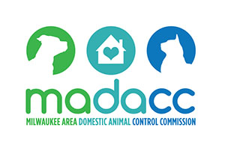
Milwaukee Area Domestic Animal Control Commission

Capital Improvement Plan

2021 - 2031

TABLE OF CONTENTS
Capital Improvement Plan 3
Looking Ahead 3

FINANCIAL SUMMARY 4

Capital Projects Dishwasher Replacement and Washer/Dryer Repairs 5
Capital Projects Roof Repair and Generator Replacement 6
Capital Projects HVAC Replacement and Building Exterior Maintenance 7
Capital Projects Crematory Maintenance 8

Capital Improvement plan

Now that the MADACC facility has been renovated, it is possible to develop a plan for future capital improvements. MADACC has completed a thorough inspection and planning process for future capital spending. The resulting Capital Improvement Plan (CIP) is a fiscally responsible approach to funding projects needed to maintain MADACC’s facilities and equipment. The plan enables municipal members to measure the impact their future contributions will have on MADACC’s operations. These capital improvements, combined with operational improvements such as adding a second veterinarian, will enhance MADACC’s ability to generate revenue and positively impact the community.
Did you know that MADACC is a nationally recognized animal control organization that is used by groups such as the ASPCA as a model for operating an animal control facility?

Looking Ahead
The CIP’s goal is to ensure MADACC provides the most cost-efficient animal control services while continuing to set new standards of care and service to residents and member communities.

Capital projects include structural improvements to the premises, purchase of equipment with a useful life of at least 5 years and unit cost of $10,000, and replacement or addition of building infrastructure and systems. All capital projects will be included in the annual MADACC budget in the Capital Projects Fund, with expenses billed to members based on animal usage. The Capital Project Fund has historically been funded at $50,000 annually. The CIP will not increase member billing.

FINANCIAL SUMMARY
MADACC Capital Improvements Projects 2020 - 2031
Project Name | FY 2020 | FY 2021 | FY 2022 | FY 2023 | FY 2024 | FY 2025 | FY 2026 | FY 2027 | FY 2028 | FY 2029 | FY 2030 | FY 2031 | Total
Security System | $25,000 |  |  |  |  |  |  |  |  |  |  |  | $55,000
Radios |  |  |  |  |  |  |  |  |  |  |  |  | $65,000
Electric Gate |  |  |  |  |  |  |  |  |  |  |  |  | $25,000
Office Furniture |  |  |  |  |  |  |  |  |  |  |  |  | $30,000
Blacktop Parking Lots |  |  |  |  |  |  |  |  |  |  |  |  | $0
Washer/Dryer |  |  |  |  | $15,000 |  |  | $10,000 |  |  | $15,000 |  | $54,125
New Roof |  |  |  |  |  |  |  |  |  | $50,000 |  |  | $50,000
New Rooftop HVAC Unit |  | $95,000 |  |  |  |  |  |  |  |  |  |  | $95,000
Replace Generator |  |  |  |  |  |  |  |  | $30,000 |  |  |  | $30,000
Exterior Building Maintenance |  |  |  | $50,000 |  |  |  |  |  |  |  |  | $50,000
Replace Cat Condos Front Office | $25,000 |  |  |  |  |  |  |  |  |  |  |  | $25,000
Replace Dishwasher |  |  |  |  |  |  | $15,000 |  |  |  |  |  | $15,000
Medical Equipment Purchase (pending budget amendment) |  |  |  |  |  |  |  |  |  |  |  |  | $10,000
Crematory Relining |  |  |  |  |  | $35,000 |  |  |  |  |  |  | $35,000
Total | $50,000 | $95,000 | $0 | $50,000 | $15,000 | $35,000 | $15,000 | $10,000 | $30,000 | $50,000 | $15,000 | $0 | $539,125
Starting Balance | $516,484 | $486,484 | $441,484 | $491,484 | $491,484 | $526,484 | $541,484 | $576,484 | $616,484 | $636,484 | $636,484 | $636,484
Ending Balance | $486,484 | $441,484 | $491,484 | $491,484 | $526,484 | $541,484 | $576,484 | $616,484 | $636,484 | $636,484 | $671,484 | $686,484

Capital Projects
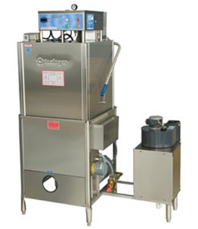
Dishwasher Replacement
MADACC has one commercial dishwasher which is vital for controlling disease and preserving animal health. The current unit has a life expectancy of 10 years and we anticipate replacement in 2026 at a cost of $15,000.
Project  Dishwasher Replacement |  |  | FY2026  $15,000 |  |  | Total  $15,000 |  |  |  |  |  |  |  |  | Capital Projects

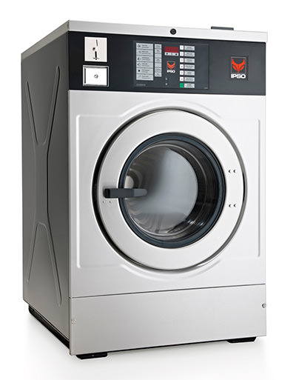
Washer and Dryer Replacements
Commercial laundry machines are some of the most highly used equipment at MADACC. Dozens of laundry loads occur daily. Commercial machines are needed to adequately sterilize linens and other items. Laundry machines require replacement every few years due to high use. The average useful life of a unit is six years. We estimate replacement of one washer or dryer approximately every three years.
Project  Washer/Dryer Replacements |  |  | FY2024/2027/2030  $15,000 or $10,000 |  |  |  | Total  $50,000 |  |  |  |  |  |  |  | Capital Projects

Capital Projects

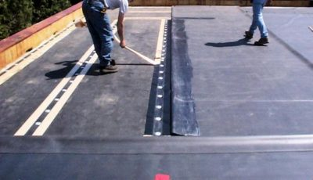
Roof Repair and/or Replacement
MADACC’s roof is frequently in need of repair. The original part of the building roof requires full resealing. This is approximately 80% of the total roof area. New additions to the building will not need roof repair or replacement at this time.
Project  Roof Resealing |  |  | FY2029  $50,000 |  |  | Total  $50,000 |  |  |  |  |  |  |  |  | Capital Projects

Generator Replacement
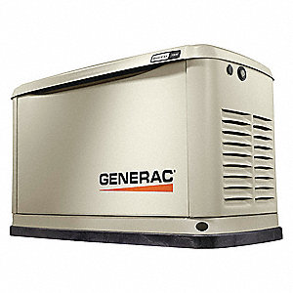
The current generator is estimated to reach the end of its useful life by 2028. Maintaining a functional generator is imperative as adequate and humane animal care is required 24/7/365. In addition, a reliable power source is needed for critical activities, including surgeries and assisting the public when there is a power outage.
Project  Replace Generator |  |  | FY2028  $30,000 |  |  |  | Total  $30,000 |  |  |  |  |  |  |  | Capital Projects

Capital Projects

Planned Rooftop HVAC Unit Replacement
MADACC’s facility has five HVAC units. The units work at full force year-round as humane animal shelter operations require uninterrupted HVAC service. Two new units were installed in 2016 during facility renovation. Three older units were replaced in 2008. The plan is to replace units as their useful life comes to an end. The current estimate is replacing one unit each in 2021, 2024, 2027 and 2030. The two newer units are expected to function through 2036.
Project  Planned HVAC Unit Replacement t |  |  | FY2021/2022  $95,000 |  |  | Total  $95,000 |  |  |  |  |  |  |  |  | Capital Projects

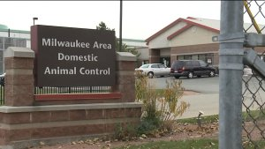
Exterior Building Maintenance
The facility’s exterior has not been painted nor
had masonry repair or resealing since 1999. The
exterior requires repair and repainting to be
weather resistant and water-tight. This prevents
leaks, cracks and other problems that shorten
the facility’s life and increase maintenance costs.
Project  Exterior Building Maintenance |  |  | FY2023  $50,000 |  |  |  | Total  $50,000 |  |  |  |  |  |  |  | Capital Projects

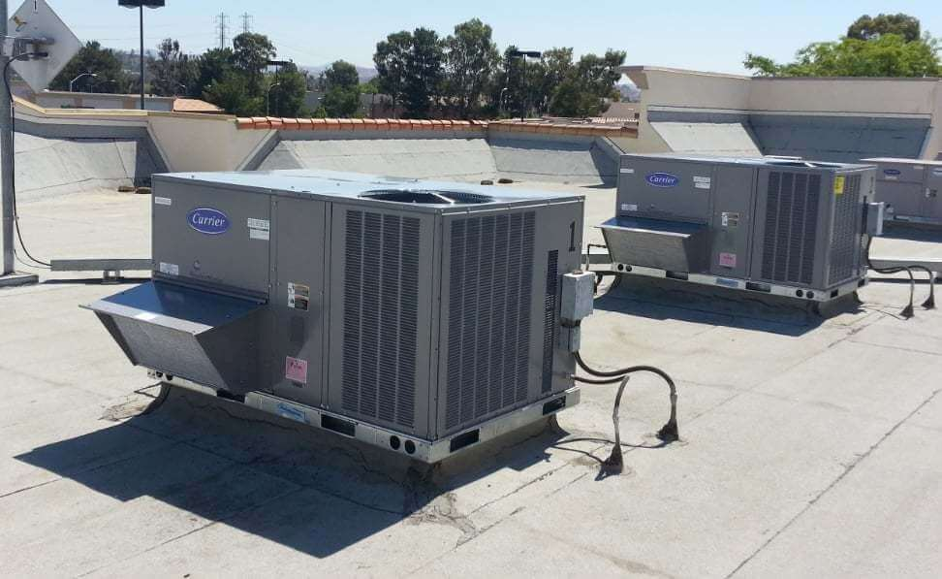

Capital Projects

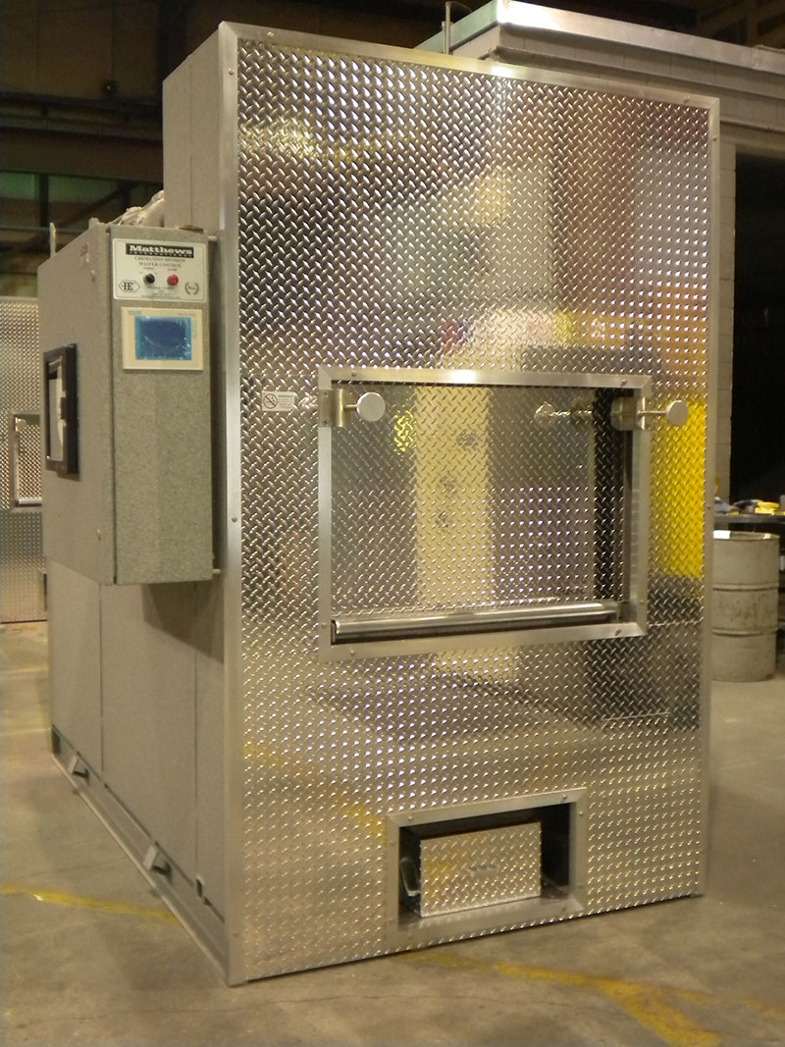
Crematory Maintenance
The new crematory is expected to have a long-life expectancy, up to 20 years. The crematory will require various on-going low cost repairs and maintenance during its life. However, at some point the refractory (the inside lining, made of cement brick) will need to be replaced. The current estimate is replacement in 2025 at a cost of $35,000. Replacement is needed to ensure the crematory operates as needed.
Project  Refractory Replacement |  |  | FY2025  $35,000 |  |  |  | Total  $35,000 |  |  |  |  |  |  |  | Capital Projects

