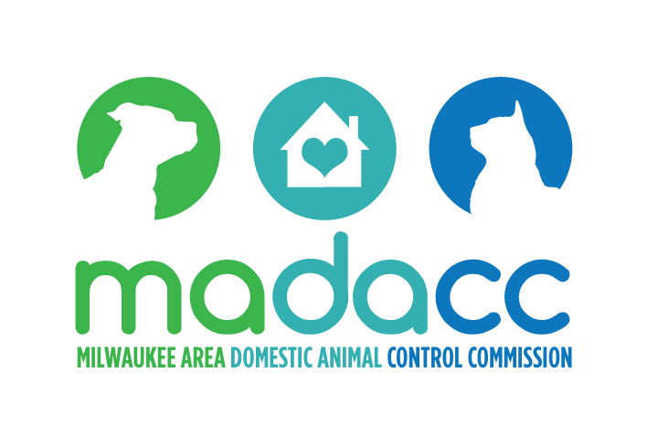

Veterinary Forensics Team
Milwaukee Area Domestic Animal Control Commission
3839 West Burnham Street, W. Milwaukee, WI ________________________________________________________________________

Scar Chart

Note: Ears removed from lateral views so wounds & scars under ears can be diagrammed

Veterinarian: ____________________________________ Date: _________________
Law Enforcement Agency: _____________________ Case #: ___________________
Dog ID #: ______________ Distinguishing Marks/Comments: ___________________
________________________________________________________________________

